Objectives:

* Using the IF Block Structure

There are 3 projects, each worth 33.3%

Homework #2 is based on Chapter 3.

Complete the 3 projects below. Be sure to use the if block structure for all three projects.

**Project #1**

**#1 print screen the output with code below here.**

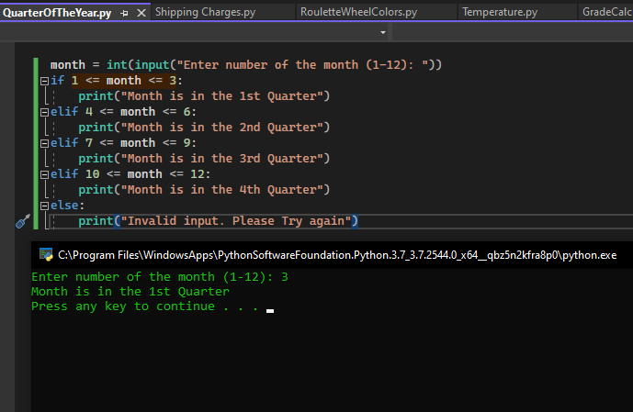

**Project #2**

**#2 print screen the output with code below here.**

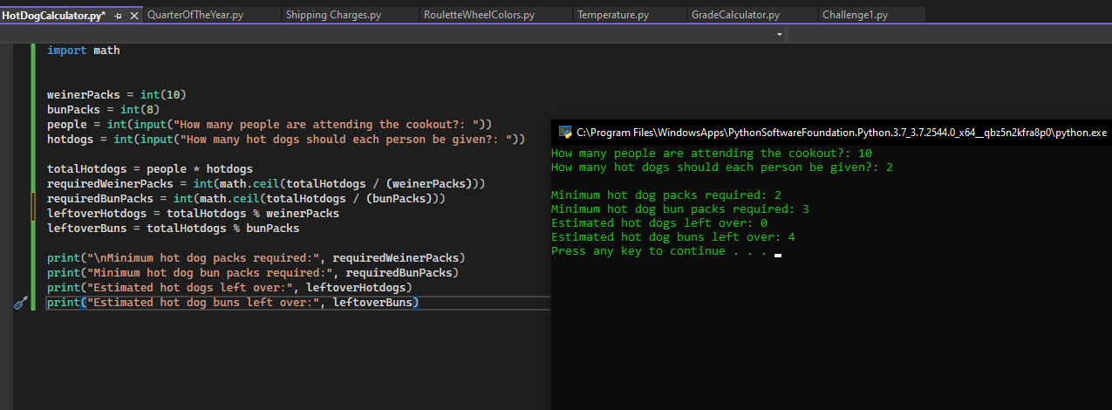

**Project #3**

**#3 print screen the output with code below here.**

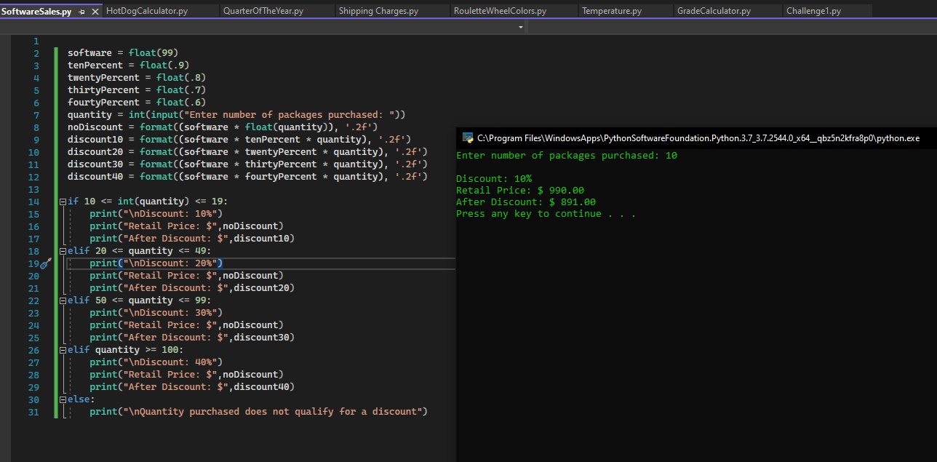

**Submit this document to Module 2 Homework**